**TIME COMPLEXITY**

**Graph showing time complexity and table having descending order of time complexity**

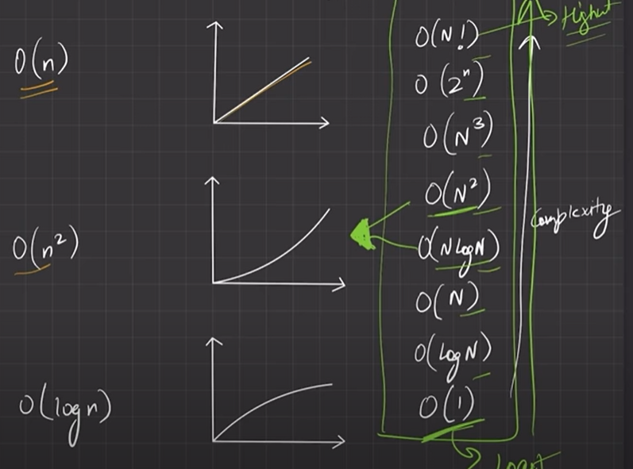

**10^8 problem technique(it is said that a computer can do upto 10^8 work in 1 sec)**

**In any problem if there is constraint and to avoid time limit exceeded error we should try to achieve the problem in specified time complexity**

**Example: 1 < n < 10^6**

**10^6 can be max value of n so we need to find a solution that takes o(nlogn) time or lower anything above this will throw tle error**

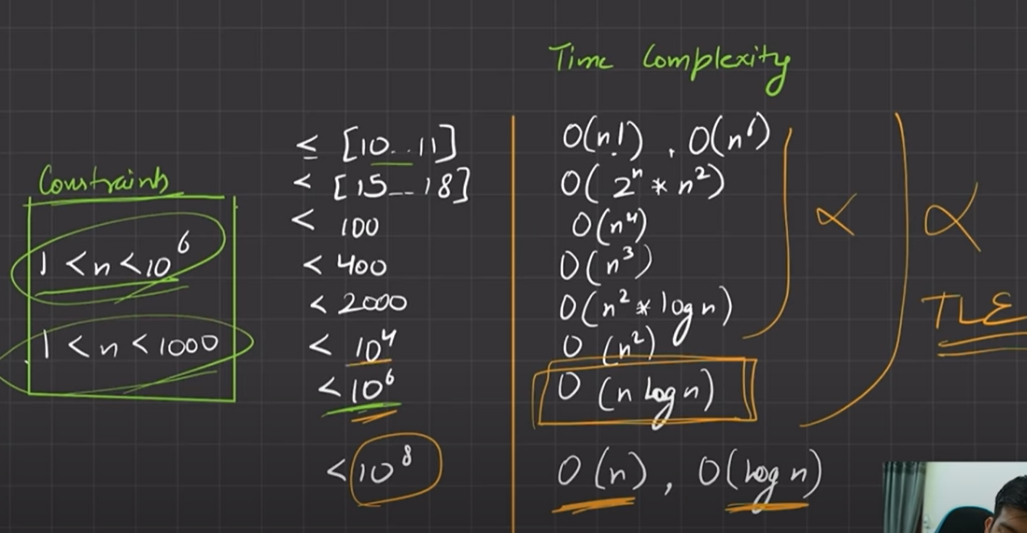

**For(i = 1;i<=n ;i++) { ----- outer loop**

**j=2**

**while(j<=n) { ------ inner loop**

**j = j^2**

**}**

**}**

**When inner loop is not dependent on outer loop(i.e I is not used to decide inner loop iteration)  
Calculate time complexity of inner and outer loop separately and multiply**

**Outer loop o(n)**

**Inner loop**

**Itr 1 2 3 a a+1**

**j 2 4 = 2^2^1 16 = 2^2^2 a = 2^2^a-1 a+1=2^2^a**

**j > n (loop broken)**

**2^2^a > n**

**2^a log 2 > log n**

**a > log log n**

**outer loop * inner loop**

**(n log log n)**